
1

Theory: Assembly language is a low-level, human-readable programming language. It uses symbols instead of binary, mapping directly to machine instructions for specific architectures. It's ideal for high-performance or hardware-specific tasks.

Convert uppercase to lowercase:
To convert an uppercase letter to lowercase in assembly language, you can use the ASCII values of the characters. Since the ASCII value of an uppercase letter is 32 less than its corresponding lowercase letter, you simply add 32 to the uppercase letter's ASCII value. First, load the uppercase letter into a register, then add 32, and finally store the result back. Here's a simple approach: move the uppercase letter into a register (e.g., `AL`), add 32 to it, and then store the result back in memory or use it as needed. This method is efficient and leverages the fixed ASCII offset between uppercase and lowercase letters.

Code:

.model small
.stack 100h

.data
var db ? ; Define an uninitialized variable

.code
main proc
; Initialize data segment
mov ax, @data
mov ds, ax

; Read a character from the keyboard
mov ah, 1
int 21h
mov bl, al

; Print a newline (Line Feed and Carriage Return)
mov ah, 2
mov dl, 10
int 21h
mov dl, 13
int 21h

; Convert to lowercase by adding 32
add bl, 32

; Display the lowercase character
mov ah, 2
mov dl, bl
int 21h

exit:
; Exit program
mov ah, 4ch
int 21h

main endp
end main
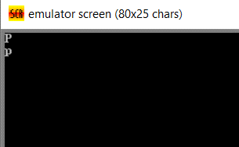
Output:

Display a string on the screen:
To display a string output in assembly language, start by defining the string in the data segment and ending it with a special character (like `$` for DOS). Then, set up the data segment by initializing the data segment register. Load the address of the string into the `dx` register and use DOS interrupt 21h with function 09h to display the string. Finally, use DOS interrupt 21h with function 4Ch to exit the program. This sequence of steps will effectively display the string output on the screen.

Code:
.model small
.stack 100h

.data
str db 'PRANTO, CSE $' ; Define a string variable

.code
main proc
; Initialize data segment
mov ax, @data
mov ds, ax

; Display the string
mov ah, 9
lea dx, str
int 21h

exit:
; Exit program
mov ah, 4ch
int 21h

main endp
end main

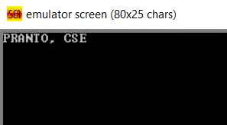
OutPut:

Conclusion: In assembly language, displaying a string involves defining the string in the data segment, initializing the data segment register, and using DOS interrupts to print the string and exit the program. This method provides direct control over output processes. It showcases the precise and efficient nature of assembly language programming.

